1-Create a ReplicaSet using the below yaml

apiVersion: apps/v1
kind: ReplicaSet
metadata:
name: new-replica-set
namespace: default
spec:
replicas: 4
selector:
matchLabels:
name: busybox-pod
template:
metadata:
labels:
name: busybox-pod
spec:
containers:
- command:
- sh
- -c
- echo Hello Kubernetes! && sleep 3600
image: busybox777
imagePullPolicy: Always
name: busybox-container
--------------------
2-How many PODs are DESIRED in the new-replica-set?
4
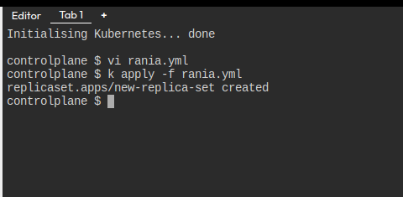

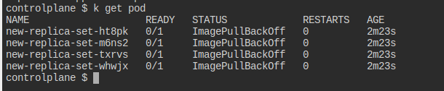
----------------------

3-What is the image used to create the pods in the new-replica-set?
Busybox777
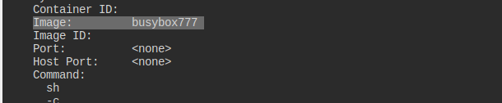
---------------------
4-How many PODs are READY in the new-replica-set?
0
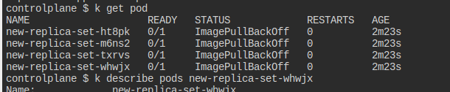
---------------------
5-Why do you think the PODs are not ready?
there is no image with that name
------------------------
6-Delete any one of the 4 PODs.
How many pods now
4
k delete pod new-replica-set-ht8pk
---------------------
7-Why are there still 4 PODs, even after you deleted one?
new one created
-----------------
8-Create a ReplicaSet using the below yaml

There is an issue with the file, so try to fix it.

apiVersion: v1
kind: ReplicaSet
metadata:
name: replicaset-1
spec:
replicas: 2
selector:
matchLabels:
tier: frontend
template:
metadata:
labels:
tier: frontend
spec:
containers:
- name: nginx
image: nginx

